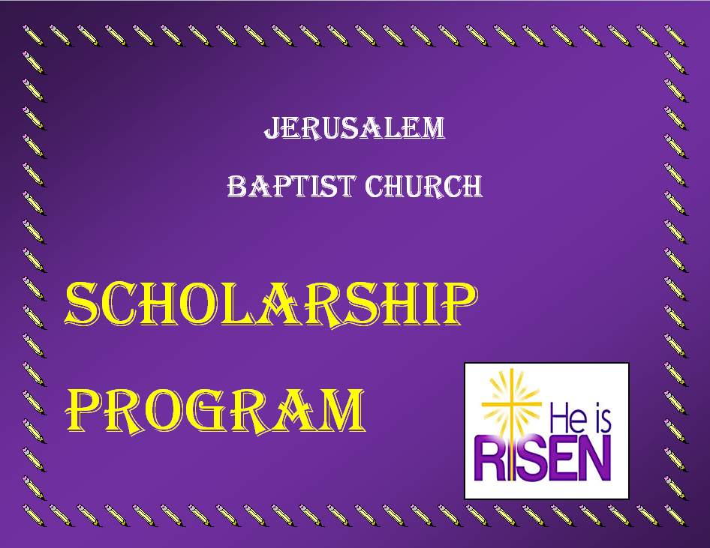

Jerusalem Baptist Church Scholarship Program

Essay Questions

You may select one of the listed questions below to write your essay. Your essay must be double-spaced, 300 typed words.
- What is your intended field of study and what have you done in your school, church and community to prepare you to succeed in the future?
- What is your definition of a leader in a community?
- Is there an individual who has been a major influence in your life that led to your decision to continue your education? If so, identify and tell why.
In addition to the essay, Please answer this question on a separate sheet of paper.
How would you propose to raise money for a scholarship fund? List the activities and describe how you would incorporate that into a fundraiser.

-------------------------------------------------------------------------------------------------------------For Scholarship Committee Use Only: Date Received ____________
Approved__________________________ Amount awarded__________________
Not Approved_____________ Reason____________________________________

Jerusalem Baptist Church Scholarship Program
A P P L I C A T I O N
Date:______________________________________________________________
Name:_____________________________________________________________
Address:___________________________________________________________
_______________________________________Phone:_____________________
E-mail:_____________________________________________________________
Are you a member of Jerusalem Baptist Church? Yes_________ No____________
Do you participate in any of the church ministries? Yes_______ No____________
If yes, which one(s)?__________________________________________________
Check one:
High School Grad._______ Name of High School:___________________________
GED____________________ Enrolled Student_____________________________
Has an accredited college, university, technical or vocational school accepted you as a student? Yes__________________ No___________________
If yes, please provide verification of acceptance/enrollment along with this application.
Name of School:_____________________________________________________
Address:____________________________________________________________
Phone:______________________ Enrollment Date:________________________
Number of units/credits:________ Field of Study:__________________________
Jerusalem Baptist Church Scholarship Program
JBCSP’s General Purpose:
The purpose of the Jerusalem Baptist Church Scholarship Program is to financially assist, through the awarding of scholarships, to those church members who are seeking higher education in fully accredited colleges, universities, technical or vocational schools. Awards from funds available will be made annually per eligible applicant. An application must be submitted for 1st or 2nd semester/term enrollment.
General Eligibility Requirements:
Generally, the applicant:
- Must be an Active member of Jerusalem Baptist Church:
*Refer to the Jerusalem Baptist Church policy and procedures
- Name on the official church roll,
- Regular attendance to Sunday worship.
- Must be a high school senior or obtained a GED and has been accepted to an accredited post-secondary, technical or vocational school.
*Scholarship applicants will be placed in two categories: graduating high school seniors and adult applicants. Applicants are described as anyone who is seeking vocational or technical training certificates of licensures, associate or bachelor degrees and currently enrolled in any accredited institution of higher learning, technical or vocational training.
3. Must submit a double spaced 300-word essay to the Scholarship Committee.
4. Must submit your answer to the question to the question about How would you propose to raise money for a scholarship fund to include details.
5. Must submit verification of enrollment from the college/university/technical/vocational school the applicant will be attending for the enrollment period. Enrollment verification may be an acceptance letter from the school or other official proof of enrollment. This must be done before an application can be considered.
6. Must currently participate in at least 1 Jerusalem Baptist Church ministry per year.
7. Must volunteer in at least 1 Jerusalem Baptist Church fundraising event per year.
*If you are not actively participating in a ministry during the rolling calendar year of the awarding of the scholarship, you must participate in at least 2 fundraising events per year.
8. Must be under the age of 26 by the end of the calendar year.
Scholarship amount to be awarded will be on the basis of full time enrollment (12 units or more) or part time enrollment (min. 9/ max 11 units).
Vocational or technical school applicants will be awarded scholarships as part time enrollees. Part time applicants can receive an amount, which is 50% of the amount full time applicants receive. Scholarship amount will be determined based on the amount of funds and number of qualified applicants.
Scholarship funds will not be awarded to Graduate School students.
The scholarship fund committee will determine the total amount of dispersed funds. Such amount shall be dispersed in equal awards based on applicant enrollment status. Participants may apply annually, if they meet eligibility requirements. In an event a student does not attend school, the money must be returned to the scholarship fund.
Note: Failure to adhere to the guidelines/procedures will prevent an applicant from having his/her application considered.
For any questions, please see a member of the Scholarship Committee.

